Lab 13

- Carry out the steps of Dijkstra's algorithm to compute the length of the shortest path between vertex V and vertex Y in the graph below. Your final answer should consist of three elements:

  - The length of the shortest path from V to Y

  - The list A[] which shows shortest distances between V and every other vertex

  - The list B[] which shows shortest paths between V and every other vertex
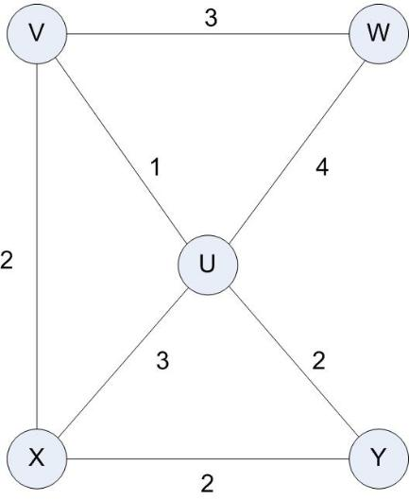

Solution:

Init | A[v] = 0 ; B = {} ; X={v}
Step1 | POOL ← {(v,w),(v,u),(v,x)}  (v,w) : A[w] = A[v] + wt(v,w) = 0 + 3 = 3  (v,u) : A[u] = A[v] + wt(v,u) = 0 + 1 = 1 (choose min)  (v,x) : A[x] = A[v] + wt(v,x) = 0 + 2 = 2  Add u into X : X ← {v,u}  A[u] = 1  B[u] = {} U {(v,u)} = {(v,u)}
Step2 | POOL ← {(v,w), (v,x),(u,w),(u,y),(u,x)}  (v,w) : A[w] = A[v] + wt(v,w) = 0 + 3 = 3  (v,x) : A[x] = A[v] + wt(v,x) = 0 + 2 = 2 (choose min)  (u,w) : A[w] = A[u] + wt(u,w) = 1 + 4 = 5  (u,y) : A[y] = A[u] + wt(u,y) = 1 + 2 = 3  (u,x) : A[x] = A[u] + wt(u,x) = 1 + 3 = 4  Add x into X : X ← {v,u,x}  A[x] = 2  B[x] = {} U {(v,x)} = {(v,x)}
Step3 | POOL ← {(v,w), (u,w),(u,y),(x,y)}  (v,w) : A[w] = A[v] + wt(v,w) = 0 + 3 = 3 (choose min)  (u,w) : A[w] = A[u] + wt(u,w) = 1 + 4 = 5  (u,y) : A[y] = A[u] + wt(u,y) = 1 + 2 = 3  (x,y) : A[y] = A[x] + wt(x,y) = 2 + 2 = 4  Add w into X : X ← {v,u,x,w}  A[w] = 3  B[w] = {} U {(v,w)} = {(v,w)}
Step4 | POOL ← {(u,y),(x,y)}  (u,y) : A[y] = A[u] + wt(u,y) = 1 + 2 = 3 (choose min)  (x,y) : A[y] = A[x] + wt(x,y) = 2 + 2 = 4  Add w into X : X ← {v,u,x,w,y}  A[y] = 3  B[y] = {B[u]} U {(u,y)} = {(v,u) , (u,y)}
Stop | X == V  So, A[] = 3 , and B[] = {(v,u) , (u,y)}

- Points about Dijkstra’s Algorithm

a. What is the shortest path from A to C in the graph below?
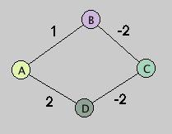

Solution:
As there are negative distances given between Vertex B and C and C and D so it can be traversed back and forth to create shorter lengths. There is no such algorithm from which we can find the shortest path between negative distances.

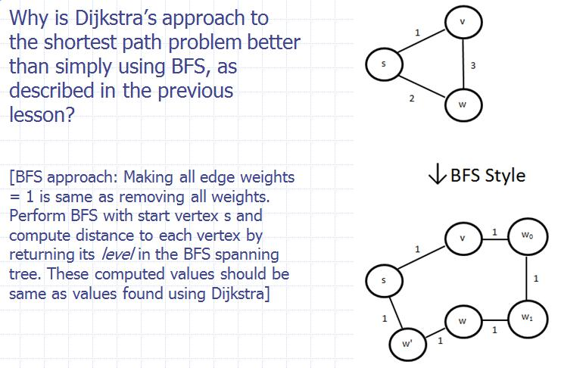
b.

Solution:
In BFS approach we make all the edge heights to 1 by adding that number of Vertices between the nodes. If the distance between vertices is big enough then adding the new vertices will slow down the performance of BFS and increase the computing time which is surely worse than Dijkstra approach i-e O(mlogn).
- Describe an algorithm for deleting a key from a heap-based priority queue that runs in O (log n) time, where n is the number of nodes. (Hint: You may use auxiliary storage as the priority queue is built and maintained. Assume there are no two nodes have the same key.) This technique is needed for the optimized Dijkstra algorithm discussed in the slides.
Solution:
We will use the Hashmap where key is the key used in priority queue and the value is the node or vertex. When we need to delete the key, use the key to look up the node in the HashMap. Then Replace the key with the key of the last node and do upheap or downheap if necessary Delete last node. The running time of this process is O(log n).

Solution4:
Step1: Sort edges | 1 | AB,CD  2 | BD,AE  3 | EF  4 | AF  5 | DF  6 | BC  7 | AD  Minimum Spanning Tree T = {}  Cluster: A , B , C , D, E, F
Step2: loop each edge
AB | Find(A) # find(B)  ↔ A # B  Add AB into T: T ← {AB}  Merge C(A) ∪ C(B) : update cluster  Cluster: A , C , D, E, F  /  B
CD | Find(C ) # Find (D)  ↔ C # D  Add CD into T: T ← {AB, CD}  Merge C(C ) ∪ C(D) : update cluster  Cluster: A , C , E, F  / /  B D
BD | Find(B ) # Find (D)  ↔ A # C  Add BD into T: T ← {AB, CD, BD}  Merge C(A ) ∪ C(C) : update cluster  Cluster: A , E, F  / \  B C  \  D
AE | Find(A ) # Find (E)  ↔ A # E  Add AE into T: T ← {AB, CD, BD, AE}  Merge C(A ) ∪ C(C) : update cluster  Cluster: A ⎯ E, F  / \  B C  \  D
EF | Find(E ) # Find (F)  ↔ A # F  Add EF into T: T ← {AB, CD, BD,AE, EF}  Merge C(A ) ∪ C(F) : update cluster  Cluster: E ⎯ A ⎯ F  / \  B C  \  D
Stop! | T.size() = n-1  => stop loop  Return T: (the minimum spanning tree)  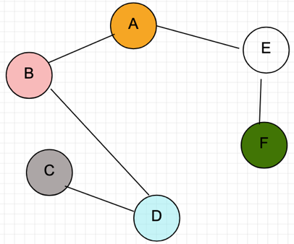  By the way, prove why stop scanning edges if T.size() = n-1  AF: Find(A ) = Find (F) ↔ A = A => Discard AF  DF: Find(D ) = Find (F) ↔ A = A => Discard DF  BC: Find(B ) = Find (C) ↔ A = A => Discard BC  AD: Find(A ) = Find (D) ↔ A = A => Discard BC
Kruskal’s Algorithm and Disjoint Sets

